KUMITE RULES

CATEGORIES

CHILDREN-JUNIOR

(UPDATED JANUARY 2018)

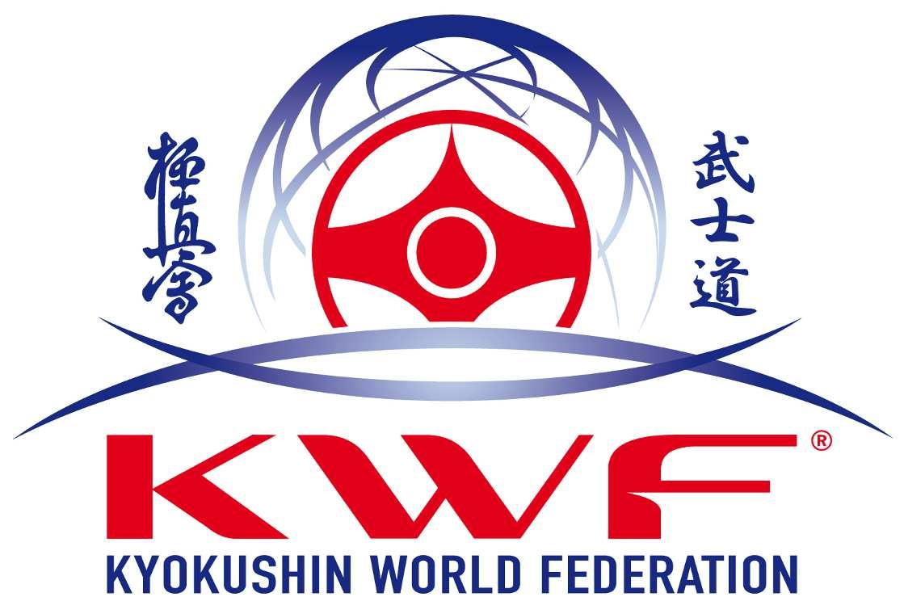

RULES FOR COMPETITORS

CATEGORIES: CHILDREN-JUNIOR.

The age for the participants for each category will be:

CHILDREN: 12 - 13 YEARS
CHILDREN: 14 - 15 YEARS
JUNIOR: 16 - 17 YEARS

GENERAL RULES

- All competitors must wear a clean white gi.
- One competitor will wear a red belt to his own one, the other one will wear his own coloured belt.
- Hands and feet nails bust be short.

OBLIGATORY PROTECTIONS

CHILDREN 12-13 YEARS
- OBLIGATORY: HELMET, GLOVES, CHEST, SHIN PADS
- OPTIONALS: KNEE, MOUTH

CHILDREN AND JUNIOR (14-15 AND 16-17 YEARS)
- OBLIGATORY: HELMET, GLOVES, SHIN PADS AND GROIN (BOYS)
- CHEST PROTECTORS FOR GIRLS
- OPTIONALS: KNEE, MOUTH

All the protections to be use at this official championship will be homologated and approved by KWF.
Under no circumstances will it be permitted to participate with other protection. Each competitor must wear his/her own protection.

Then, show the protections to be used in the competition.

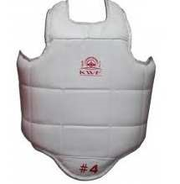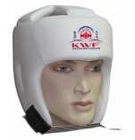
CHEST PROTECTOR SHIN PADS HELMET
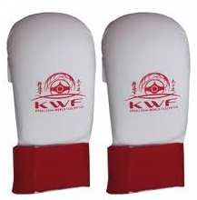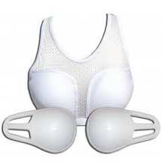
GLOVES (FROM 12 TO 13 YEARS) CHEST PROTECTOR FOR GIRLS

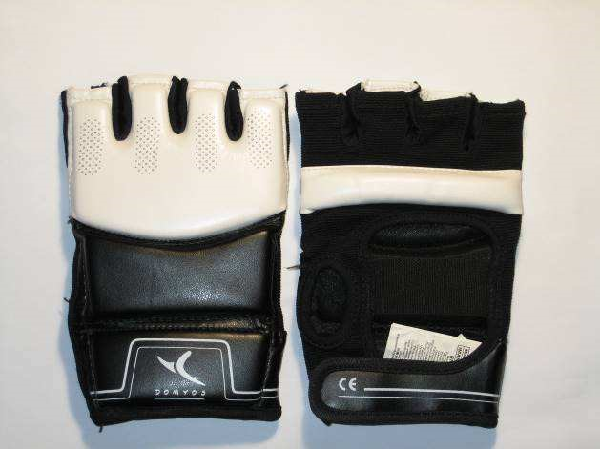
GLOVES (FROM 14 TO 17 YEARS OLD)

Another type of protections will be allowed if they offer the same level of protection.

In the case that one competitor gets injured the use of bandage or any other material of protection must be revised by the official doctor of the competition or the Supreme Judge. Whatever the decision is, this will be final and obligatory for the competitors.

WEIGHT CATEGORIES (BOYS)

CHILDREN (12-13 years)
-40kg -50kg +50kg

CHILDREN (14-15years)
-55kg -65kg +65kg

JUNIOR (16-17 years)
-60kg -70kg -80kg + 80 kg

WEIGHT CATEGORIES (GIRLS)

CHILDREN (12-13 years)
-45kg +45kg

CHILDREN (14-15years)
-50kg +50kg

JUNIOR (16-17 years)
-50kg - 60kg +60kg

REFEREE AND JUDGES

- – All the matches must include a minimum of 4 judges and 1 central referee. The central referee will direct the match and give the orders.

- –When a decision is taken in the competition, each judge and the referee will have one single vote.

- –The jury of judges and the revision panel will have the same authority on the match, final decision will be given to the Supreme Referee.

KUMITE (figting)

Basic Rules:

-Duration of the bouts:
CHILDREN 12-13 YEARS : 2 minutes with obligatory decision.
CHILDREN 14-15 YEARS: 2 MINUTES + extension of 1,5' in case of hikiwake, with obligatory decision.

JUNIOR: 2 min. /2 min. / weight (3 kgs) /1 min. with obligatory decision.

In Junior category, weight difference is 3 kg or more. If the weight difference is less than 3 kg, one extra extension will take place with obligatory final decision. (one minute)

-The Organiser of the championship and the Supreme Judge can change the duration of the matches.
-In all the categories, a winner will be declared, whenever an Ippon is awarded or 2 Waza-aris.(half points). This is similar as with the adult rules.
Note:Two half-points (Waza-aris) are one Ippon.

EXTENSIONS (Enchosen)

It is only possible to have extensions in the categories CHILDREN and JUNIOR, 14-15 years and 16-17 years.

TIME

The duration of the match will start from the moment that the referee says “Hajime”.

VICTORY BY (IPPON)

1.-Excluding the techniques which are considered fouls, one fist strike (tsuki) or a leg technique (keri) or elbow (hiji) etc. that one competitor execute on a recognized area of the body and puts down an opponent. As a result of a techniques a competitor loses the desire to continue to fight within 5 seconds or more, such technique will be considered Ippon.
IPPON will be valid whenever 3 out of 5 members of the referee team take such decision.
2. Whenever one of the competitors loses the will to continue to fight, the other competitor will be declare winner by Ippon.

HALF POINT (WAZA-ARI)

On the following cases and always under the referees decision one half point Waza-ari may be awarded.

1. Excluding the techniques which are considered fouls, any strike realized with fist, leg or elbow, and causes effective effect on the other competitor. Or even puts down him/her for a period less than 5 seconds and then recover his/her position standing up or lose the desire to continue the match. Then he/she will be awarded (Waza-ari). Also whenever one competitor loses the balance after receiving a technique (fist or leg) a Waza-ari may be given under the criteria of the referees team.
Two waza-aris are one Ippon.

3. Whenever one of the competitors execute a leg technique (jodan) and such techniques counts with the recognized and necessary requirements like correct attitude, application, enough control, zanshin, timing or even distance according to the referees team criteria could be considered waza-ari. Also light contact on the helmet could be considered half point - waza-ari.

VICTORY BY HANTEI

Whenever there is no Ippon or Waza-ari, a victory will be given by decision. The decision will be valid whenever 3 out of 5 members of the referee team are in majority and take such decision.

This criterion to take such decision will have the following priority:

The effectiveness of the techniques.
The development of combinations and variation of techniques, fist and legs.
Tactics and strategy of combat.
Number of executed techniques.
If one of the competitors has 2 fouls (genten ni) and one waza-ari this will be cancelled by the 2 fouls, Genten ni.
In the case of none of them have half point or fouls, the victory will be awarded by decision.
A victory will be awarded whenever a disqualification takes place or one of the competitors retires from competition.

The victory to one competitor can be awarded if there is a difference of two fauls.

Examples:
SHIRO | AKA | RESULTADO POSIBLE
NO SCORE | CHUI | SHIRO/AKA/HIKIWAKE
NO SCORE | GENTEN ICHI | SHIRO
CHUI | GENTEN ICHI | SHIRO/AKA/HIKIWAKE
CHUI | GENTEN NI | SHIRO
GENTEN ICHI | GENTEN NI | SHIRO/AKA/HIKIWAKE
NO SCORE | GENTEN ICHI / WAZA-ARI | AKA
NO SCORE | GENTEN NI / WAZA-ARI | SHIRO/AKA/HIKIWAKE
CHUI | GENTEN NI / WAZA-ARI | SHIRO/AKA/HIKIWAKE
GENTEN ICHI | GENTEN NI / WAZA-ARI | AKA

FOULS (HANSOKU)

The following actions will be considered fouls:

Direct technique with no control or direct to the FACE, ei. Jodan Mae Geri, uchi kakato, jodan yoko geri, tobi geri jodan, jodan ushiro mawashi geri.
Contact to the face or neck, even light one with hands, fists o elbow.
In the categories children12-13 years no gedan techniques are allowed. E.i. gedan mawashi geri.
To attack with the punches in no permitted areas. For example: to punch intentionally to the arms in CHILDREN categories techniques to the groin (kin-geri) Strikes with the head.
Attacks to the opponent whenever he/she is down.
Attacks to the dorsal spine.
Grabbing repeatedly to the opponents neck or body.
Grabbing the uniform (dogi) legs or arms.
Pushing with fist or hands.
Repeating actions like fall to the floor, alter executing techniques kakenige.
Going out of the fighting area continuously. (Jogai)
Direct attacks to the joints and knee from the front.
Any other actions that under the criteria of the referees team can be considered fouls or delivered actions.

The result of the fouls will be one warning, chui. Two warnings will be one official foul. Genten-ichi. Three fouls will be two official fouls Genten-ni. Four fouls will be a Genten-san and will be automatic disqualification.

GENTEN

The following situations will be considered one foul. a) Two fouls.
- Deliberated fouls.
- Any other actions considered by bad altitude by the Central Referee during the match.

DISQUALIFICATION (SHIKKAKU).

The following situations will be considered disqualification:

Three fouls (Genten-san= Shikkaku).
Not following or obey the orders and instructions of the Referee during the match.
Violence actions, incorrect attitudes
If a competitor does not show any will to fight for one minute and not executing any technique he/she will be disqualified.
The competitors who are coming late and are not present when the match shall start will be disqualified.
A physical incapacity that may happen during the competition might permit the competitor to retire whenever his/her injury has been examined by the official doctor of the competition. This decision will be final.

ACCIDENTS

Whenever one of the competitors gets injured, and the doctor advices the competitor to continue fighting and still the competitor refuses to fight, such competitor will lose the match.

In case of injuries that may happen during the competition, and are declared casuals and are not caused by the competitor(s), results in that one competitor will not continue to fight he/she will be declared loser of the match.

In the case of injuries that it may happen during the competition and are declared casuals and even are no responsible none of the competitors or one or both of them is not able to continue but may incapacity one of them or both may be injured the one who refuses to continue will be declared loser.

In any case, KWF or any of the Board members of this organisation will not be responsible for any accident or injury that may happen in any competition organised by KWF.
It is the solely responsibility of the competitor to arrange with an individual insurance before the matches start.

Any other matter which is not contemplated in these competition rules and may come up on the competition day, will be discuss by the Chief Referee and the Supreme Judge and the decision will be final.

Checked by:
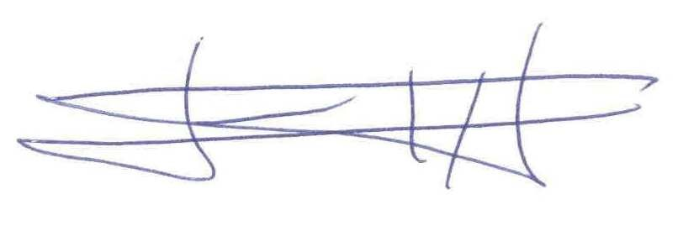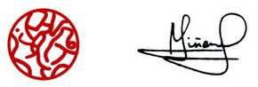
Shihan Fernando Pérez Shihan Antonio Piñero

